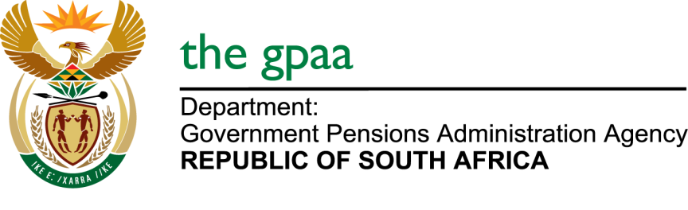

CLOSING DATE: 24 FEBRUARY 2020
REPAIRS AND MAINTENANCE OF ELECTRICAL INFRASTRUCTURE BID NO GPAA 04-2020
NAME OF BIDDERS

- SFM electrical & refrigeration
- Tsebo
- Globalspek group
- Envoromongz project (Pty) Ltd
- Matase inductrial solutions
- Buwesi generators cc
- Lengwati electrical cc
- Excellent electrical projects
- Vagwena holdings
- Robus engineering training services
- Realtime trading and projects
- Lumacon
- Imbawula technical services and supplies group
- Andre Els engineering
- Roncon cc

